RandomForestClassifier

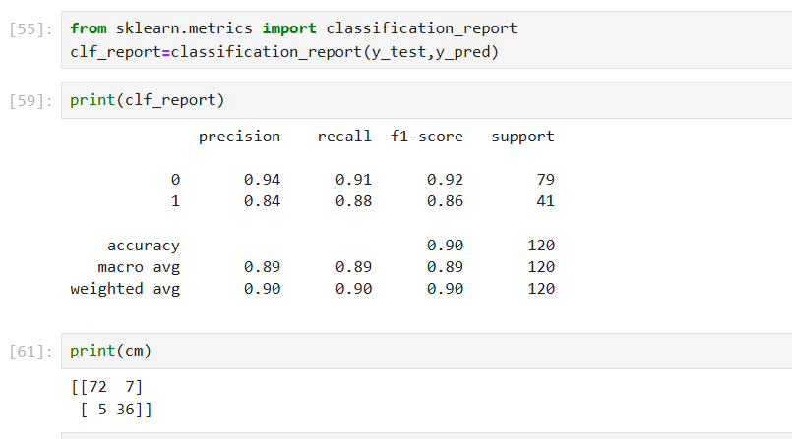

1. What is the overall performance of the model?

Accuracy : Correctly identified class/Total test set passed

= 72+36/72+7+5+36 = 0.90

Accuracy is 90%

1. What is the correct classification of not purchased?

Recall value of “0” – 0.91

Recall : Correctly identified class/correctly identified class +Wrongly identified class

72/72+7 = 0.91

1. What is the correct classification of purchased?

Recall value of “1” 🡪 0.88

Recall = 36/36+5 = 0.88

1. How does the model correctly predict truly positive instances among the positive classes for purchased?

Precision🡪 36/36+7 = 0.837 = 0.83

1. How does the model correctly predict truly positive instances among the positive classes for not purchased?

Precision🡪 72/72+5 = 0. 0.935= 0.94

1. What is the stability of the model for purchase?

F1 Score 🡪 2\*Recall(Purchase)\*Precision(Purchase)/Recall(Purchase)+Precision(Purchase)

F1 Score 🡪 2\*0.88\*0.84/0.88+0.84 = 1.478/1.72 = 0.859 = 0.86

1. What is the stability of the model for not purchase?

F1 Score 🡪 2\*Recall(Purchase)\*Precision(Not Purchase)/Recall(Not Purchase)+Not Precision(Not Purchase)

F1 Score 🡪 2\* 0.91 \*0.94/0.91+0.94 = 1.71/ 1.85= 0.859 = 0.92

1. What is the macro average of Recall?

Macro Average = Recall(Purachase)+Recall(NotPurchase)/2

= 0.88+0.91 / 2 = 0.895

1. What is the macro average of Precision?

Macro Average = Precision(Not Purchase)+Precision(Purchase)/2

= 1.78/2 = 0.89

1. What is the macro average of f1 Score?

Macro Average=F1 Score(Purchase)+F2 Score(Not purchase)/2

= 0.92+.86/2 = 0.89

1. What is the Weighted Average of Recall?

Weighted Average = Recall(Purchase)\*41/120 +Recall(Not Purchase)\*79/120

Weighted Average = 0.88\*0.341 +0.91\*0.658 = 0.300+0.598 = 0.898 = 0.90

1. What is the Weighted Average of Precision?

Weighted Average = Precision(Purchase)\*41/120 +Precision(Not Purchase)\*79/120

Weighted Average = 0.84\*0.341 +0.94\*0.658 = 0.286 +0.618 = 0.904 = 0.90

1. What is the Weighted Average of f1Score?

Weighted Average = F1Score(Purchase)\*41/120 +F1Score(Not Purchase)\*79/120

Weighted Average = 0.86\*0.341 +0.92\*0.658 = 0.293 +0.605 = 0.898 = 0.90

DecisionTreeClassification:

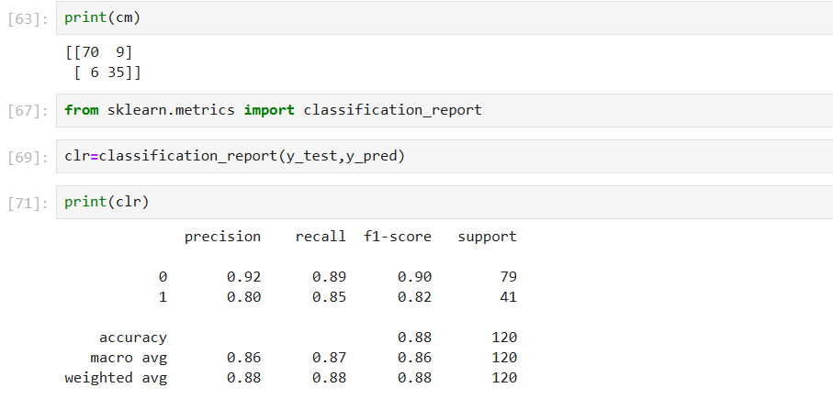

1. What is the overall performance of the model?

Accuracy 🡪 88%

1. What is the correct classification of not purchase?

Recall of “0” 🡪 89%

1. What is the correct classification of purchase?

Recall of “1”🡪 85%

1. How does the model correctly predict truly positive instances among the positive classes for purchased?

Precision🡪 35/35+9 = 0.795 = 0.80

1. How does the model correctly predict truly positive instances among the positive classes for not purchased?

Precision🡪 70/70+6 = 0.921= 0.92

1. What is the stability of the model for purchase?

F1 Score 🡪 2\*Recall(Purchase)\*Precision(Purchase)/Recall(Purchase)+Precision(Purchase)

F1 Score 🡪 2\*0.80\*0.85/0.80+0.85 = 1.36/1.65 = 0.824 = 0.82

1. What is the stability of the model for not purchase?

F1 Score 🡪 2\*Recall(Purchase)\*Precision(Not Purchase)/Recall(Not Purchase)+Not Precision(Not Purchase)

F1 Score 🡪 2\* 0.89 \*0.92/0.89+0.92 = 1.637/ 1.81= 0.859 = 0.904= 0.90

1. What is the macro average of Recall?

Macro Average = Recall(Purachase)+Recall(NotPurchase)/2

= 0.85+0.89 / 2 = 0.87

1. What is the macro average of Precision?

Macro Average = Precision(Not Purchase)+Precision(Purchase)/2

= .80+.92/2 = 0.86

1. What is the macro average of f1 Score?

Macro Average=F1 Score(Purchase)+F2 Score(Not purchase)/2

= 0.90+.82/2 = 0.86

1. What is the Weighted Average of Recall?

Weighted Average = Recall(Purchase)\*79/120 +Recall(Not Purchase)\*41/120

Weighted Average = 0.89\*79/120 +0.85\*41/120 =0.89\*0.658 +0.85\*0.341 = 0.585+0.290 = 0.875=0.88

1. What is the Weighted Average of Precision?

Weighted Average = Precision(Purchase)\*41/120 +Precision(Not Purchase)\*79/120

Weighted Average = 0.80\*0.341 +0.92\*0.658 = 0.2728 +0.605= 0.877 = 0.88

1. What is the Weighted Average of f1Score?

Weighted Average = F1Score(Purchase)\*41/120 +F1Score(Not Purchase)\*79/120

Weighted Average = 0.82\*0.341 +0.90\*0.658 = 0.279 +0.592= 0.871 = 0.87

Support Vector Machine(SVC)

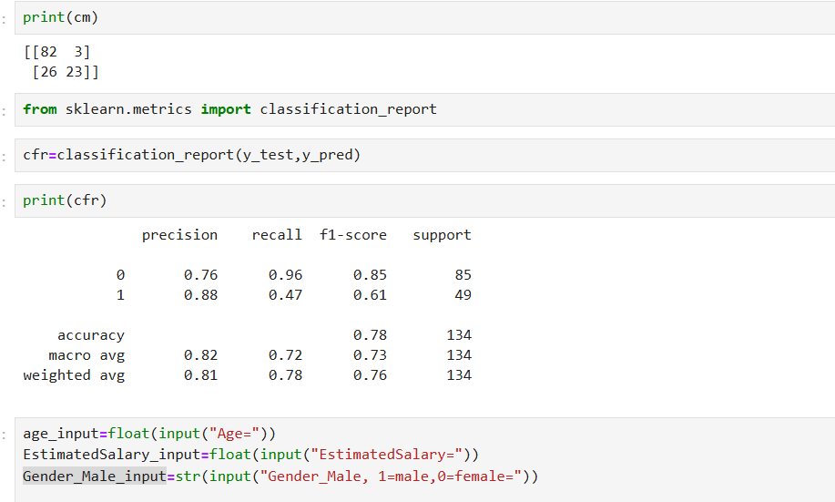

1. What is the performance of the model?

Accuracy 🡪 0.78 🡪78%

1. What is the correct classification of purchase?

Recall 🡪 Purchase (1) 🡪 23/23+26🡪0.469 🡪 0.47 -> 47%

1. What is the correct classification of Non Purchase?

Recall -> Not Purchase(0) 🡪 82/82+3 = 0.964 🡪 0.96 🡪 96%

1. What is the stability(Precision) of the model or purchase?

Precision -> Purchase(1) -> 23/23+3 = 0.884 🡪 0.88 🡪 88%

1. What is the stability of the model for Not Purchase?

Precision 🡪 Not purchase🡪 82/82+26 🡪0.759🡪 0.76🡪 76%

1. What is the F1Score of the model for purchase?

F1 Score 🡪2\*Recall(Purchase)\*Precision(Purchase)/Recall(Purchase)+Precision(Purchase)

* 2\*(0.47\*0.88)/(0.47+0.88) 🡪2\*0.4136/1.35 🡪0.8272/1.35 🡪0.612🡪61%

1. What is the F1 Score value of the model for Not Purchase?

F1 Score= 2\*Recall(Not Purchase)\*Precision(Not Purchase)/ Recall(Not Purchase)+Precision(Not Purchase)

* 2\*(0.96\*0.76)/(0.96+0.76)🡪 2\*0.7296/1.72 🡪1.4592/1.72🡪0.848 🡪 85%

1. What is the value of macro average for Recall?

Macro Average of Recall 🡪 Recall(Purchase) +Recall (Not Purchase) /2

🡪0.96 + 0.47 /2 =1.43/2🡪 0.715🡪 0.72

1. What is the value of Macro Average for Precision?

Macro average for Precision(Purchase) +Precision(Not Purchase)/2

* 0.88+0.76/2🡪 1.64/2 🡪 0.82

1. What is the macro average for F1 Score?

Macro Average of F1 Score =F1Score purchase+F1 score Not Purchase/2

* 0.85+0.61/2 🡪1.46/2 🡪 0.73

1. What is the weighted average of Recall?

Weighted Average🡪 Recall(Purchase)\*49/134+Recall(Not Purchase)\*85/134

* 0.47\*0.365+ 0.96\*0.634 🡪0.171+0.608 🡪0.779 -> 0.78

1. What is the weighted average of Precision?

Weighted Average of Precisoin 🡪 Precision(Purchase)\*49/134 + Precision(Not Purchase)\*85/134

* 0.88\*49/134+0.76\*85/134 🡪 0.88\*0.365+0.76\*0.634
* 0.321+0.481 🡪 0.802🡪 80%

1. What is the weighted average of F1 score?

Weighted average of F1 Score 🡪 F1Score(purchase)\*49/134+F1 Score Notpurchase)\* 85/134

* 0.61\*0.365+0.85\*0.634🡪 0.222+ 0.538 🡪 0.76